Weldments
Weldment
- Some brackets have small "window" cutouts
  - Use a wire feed welder to reach into these areas
- Select the location wisely
  - For some locations it is hard to weld all the way around the cutout
  - Unless the instruction says to "tack weld", you should weld all the way around the cutout
    - But not the corners
- IMPORTANT: Ensure that either the master switch is OFF or the negative terminal of the battery is isolated before welding on the machine. Damage to electronic components is possible if this is not done.
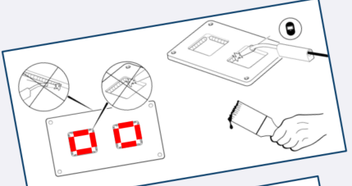
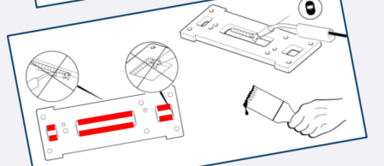
▪ NOTE: Different requirements for different brackets
▪ Stagger the welding to Not overheat nor warp any one area
– Think of it like the sequence for tightening the head on an engine
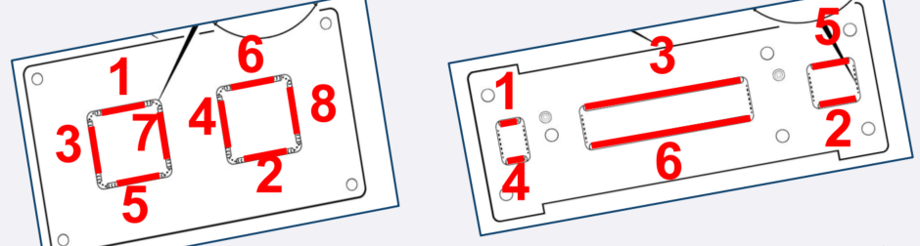
- Precisely follow bracket location measurements in installation docs
- Differences may be present with armored cabling system
- NOTE: If instructions are not followed please see pictures
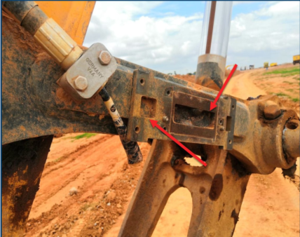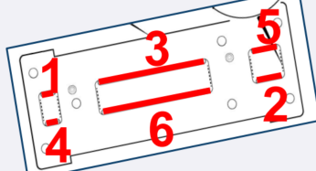
Examples of Poor Welding
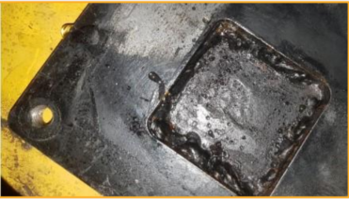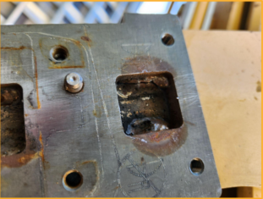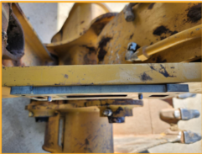
Acceptable Welding Standards
